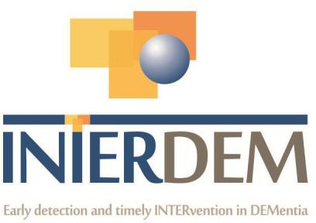

INTERDEM MEMBERS – BRIEF CURRICULUM VITAE
Please complete this document (no more than 3 pages) and return to christine Bailey on
christine.bailey@nottshc.nhs.uk

Please can you also add a picture of yourself

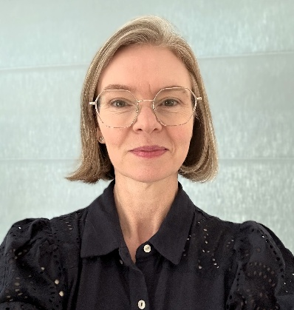

NAME: Michelle Parker
TITLE: Dr

PROFESIONAL GROUPING: Nurse

WORK ADDRESS:
Department of Nursing,
School of Health and Medical Sciences,
City St George’s, University of London
Northampton Square
London EC1V 0HB

TEL. WORK/WORK MOBILE: 020 7040 5514

EMAIL ADDRESS: michelle.parker@citystgeorges.ac.uk

WEBLINK: https://www.citystgeorges.ac.uk/about/people/academics/michelle-parker

PRESENT POSITION (e.g. Director of ………): Senior Lecturer in Adult Nursing

HIGHEST ACADEMIC QUALIFICATION (e.g. PhD, MD etc.): PhD
YEAR OF PHD QUALIFICATION: 2021
PROFILE OF MEMBER:

I am currently a senior lecturer in adult nursing at City St George’s, University of London where I teach research methods and modules on ageing, frailty and dementia as part of the BSc and MSc pre-registration nursing programmes, MSc Advanced Clinical Practitioner programme, Public Health & Specialist Community Nursing programmes and I am module lead for a level 7 module on Leading Care in Dementia and Frailty.

My clinical background is in the acute care of older people and dementia with extensive experience working in the NHS including as a Consultant Nurse for Older People. This included leading an Older People’s Psychiatric Liaison Service, providing clinical consultation and support in the management of swallowing and eating problems in advanced dementia, setting up Dementia and Delirium teams within acute hospital services and working with a community memory service supporting assessment and diagnosis of dementia following acute hospital admission.

My PhD - 'We need to talk about dementia. The role of stigma and the social network in preventing help seeking for a diagnosis of dementia' was a critical realist mixed methods study exploring the experiences of carers of people diagnosed with dementia during or following an acute hospital admission when they were not seeking a diagnosis. My current research interests focus on facilitating support for people with dementia and their carers within general practice from pre-diagnosis onwards, specifically within the role of General Practice Nurses.

AREAS OF EXPERTISE:

Help seeking for dementia diagnosis and stigma associated with diagnosis, Dementia assessment and diagnosis,
Care of people with dementia in acute hospital settings, Carer experiences and support.

KEY PUBLICATIONS (Max. 5):

Parker, M., Barlow, S., Hoe, J. and Aitken, L.M. (2022). The Bubble of Normalisation: A Qualitative Study of Carers of People With Dementia Who Do Not Seek Help for a Diagnosis. Journal of Geriatric Psychiatry and Neurology, 35(5), pp. 717-732. doi:10.1177/08919887211060018

Parker, M., Barlow, S., Hoe, J. and Aitken, L. (2020). Persistent barriers and facilitators to seeking help for a dementia diagnosis: a systematic review of 30 years of the perspectives of carers and people with dementia. International Psychogeriatrics, 32(5), pp. 611-634. doi:10.1017/s1041610219002229

Parker, M. and Power, D. (2013). Management of swallowing difficulties in people with advanced dementia. Nursing Older People, 25(2), pp. 26-31. doi:10.7748/nop2013.03.25.2.26.e416

RELEVANT RESEARCH ACTIVITY:
Please indicate for past 5 years only (i) Grants Awarded: Names of investigators; Years; Title of Project; name of awarding agency (ii) PhD and other projects: Title, start or competed date.

(i)Grants awarded:

NIHR Development and Skills Enhancement Award £164,906.63 : Dr Michelle Parker (personal career award); September 2025 – July 2027. Focus of award is enhancing skills in the development and testing of complex interventions and undertaking preliminary work PPIE work with people living with dementia, their carers and general practice nurses in order to prepare a post doctoral fellowship application to co-produce and test an intervention to help general practice nurses support people living with dementia and their carers from pre-diagnosis onwards. NIHR

Pump Priming Award £5,683.69: Dr Michelle Parker & Dr Allan Hicks; 2024-2025; Understanding the role of GP nurses and community nurses in talking to older people about memory problems; City St George’s University of London

(ii)PhD and other projects

Doctor of Philosophy in Nursing: 'We need to talk about dementia. The role of stigma and the social network in preventing help seeking for a diagnosis of dementia'. Completed April 2021

CURRENT RESEARCH INTERESTS/ONGOING PROJECT TITLE:

My research interests are in supporting people living with dementia to receive timely diagnosis and support. This includes addressing stigma and facilitating conversations about dementia and brain health and supporting health professionals to have these conversations.

My current research projects involve supporting general practice nurses to talk to people about dementia and support people with dementia and their carers as part of their day to day role. This involves a nationwide online survey for general practice nurses to understand their current role and possible future roles in supporting people living with dementia and their carers from pre-diagnosis onwards. This will be followed by focus groups with people living with dementia and carers to explore how general practice nurses could or have supported them and focus groups with general practice nurses to explore what could help them in their day-to-day practice to support people living with dementia and their carers.

HOW DO YOU INTEND TO CONTRIBUTE TO INTERDEM:

I intend to share my research findings through attendance at meetings and symposia and would seek to work with Interdem members to collaborate on current and future projects which support the aims of Interdem.
I would be keen to join an Interdem taskforce and my current research interests could align with the Prevention Taskforce as one of the potential roles of general practice nurses could be incorporating discussions around brain health into their consultations, which has the potential to help reduce the stigma of dementia and encourage help seeking for a timely diagnosis.
I would also intend to disseminate the work of Interdem within my own networks to encourage further participation and knowledge sharing.

