Course information
Master's Courses in Dementia Care for Occupational therapists and Physiotherapists
60 credits, web-based distance learning
Karolinska Institutet offers web-based Master's Courses in Dementia Care for Occupational therapists and Physiotherapists. An efficient dementia care will benefit not only your patient, but also their families, your organisation and the society at large.
This unique opportunity is offered in cooperation with Stiftelsen Silviahemmet, and participants who complete the courses will earn the title of Silviaarbetsterapeut (Silvia Occupational therapist) or Silviafysioterapeut (Silvia Physiotherapist). The diploma and the official pin of completion will be presented by H. M. Queen Silvia of Sweden at a ceremony.
The challenge of dementia  Dementia disease is a major cause of disability and dependency and has physical, psychological, social and economic impact on patient, care givers, families and society. You will gain competencies to meet the needs of modern dementia care and learn strategies to develop efficient and evidence-based care.  Target group  Occupational therapists and Physiotherapists who want to develop their knowledge and skills in the field of dementia.  These Master’s courses are tailored to suit both occupational therapists and physiotherapists. Some of the courses are generic for both professions, while others may be part of a specialist track. The training will lead to a Master’s degree in Occupational Therapy or Physiotherapy, with specialisation in dementia.  Why should you participate?  - You will get a deeper understanding and knowledge of people with dementia in different stages of the disease, and how it is to live with.  - You will learn to work evidence-based and person-centred, with complex problems.  - You will gain advanced knowledge directly linked to your profession.  . | Web-based training  These Master’s courses in Dementia Care are based on research and best practices. It focuses on interactive, student-centred learning.  Short lectures and seminars are broadcasted via our learning platform. The lectures are supplemented with individual studies and assignments. The majority of the literature and lectures will be available via the learning platform. The learning activities will be closely related to your profession, enabling you to use the results in your everyday work with immediate effect.  Fee  The price for the Master’s courses is 158 000 SEK (one hundred and fifty-eight thousand SEK) excluding VAT. VAT may be added to all prices, contact us for more information.  Time  The training starts on November 11th 2016. The studies are entirely web-based and equal to a one-year master's degree. The master’s courses take place over two years as part-time studies to enable you to work at the same time.

Course information
Master’s Courses in Dementia Care for Occupational therapists and Physiotherapists
Course content  - Dementia from cell to society  - General principles for scientific work  - Implementation of evidence-based physiotherapy/ occupational therapy for people with dementia  - Degree Project for Master’s Degree in Occupational Therapy or Physiotherapy, with specialisation in dementia  Entry requirements  In order to meet the entry requirements, applicants must have a bachelor’s degree or a professional degree equivalent to a Swedish bachelor's degree of  at least 180 credits in occupational therapy or physiotherapy. The degree must come from an internationally recognised university. The language of instruction is English, and applicants are therefore required to have a good proficiency in English.  Application  The Master’s courses are offered as contract education and can be commissioned only by a legal entity – an organisation, company or the equivalent. Please visit ki.se/epe/dementia for more information about the requirements and application process.  Application deadline: 2016-09-19.  Please note that the course is subject to the condition that we receive a sufficient number of participants.  For more information, please contact  If you have any questions, please contact us for more information and personal advice. You are welcome to contact us by phone or email.  Kristoffer Mörtsjö, Project Coordinator  Karolinska Institutet Executive and Professional Education  Email: kristoffer.mortsjo@ki.se  Telephone: +46 8 524 860 32 | Responsible department  Department of Neurobiology, Care Sciences and Society, Karolinska Institutet, Division of Occupational Therapy and Division of Physiotherapy  Course management:  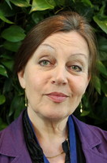 Louise Nygård, PhD, Professor of Occupational Therapy, Reg OT, Division of Occupational Therapy  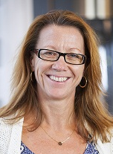 Elisabeth Rydwik, PhD, Associate Professor, Reg PT, Division of physiotherapy  Anna Brorsson,  PhD, Reg OT,  Division of Occupational Therapy  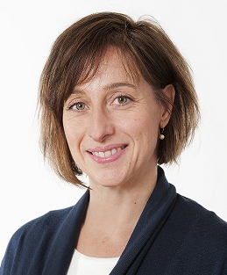 Anna Pettersson, PhD, Reg PT, Division of Physiotherapy  Karolinska Institutet is one of the world’s leading medical  universities. Its mission is to contribute to the improvement of human health through research and education. Karolinska Institutet accounts for over 40 per cent of the medical academic research conducted in Sweden and offer the country’s broadest range of education in medicine and health sciences. Since 1901 the Nobel Assembly at Karolinska Institutet has selected the Nobel laureates in Physiology  or Medicine.  Stiftelsen Silviahemmet was founded by H.M. Queen Silvia of Sweden in 1996. Silviahemmet works with care and education as well as promoting research in the field of dementia – aiming at the highest possible quality of life regardless of the severity of the disease. Together with the Stockholm Gerontology Research Centre, Silviahemmet leads the national competence center, the Swedish Dementia Centre.

