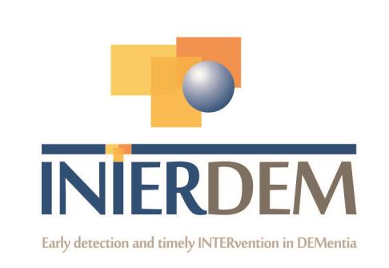
INTERDEM MEMBERS – BRIEF CURRICULUM VITAE
Please complete this document (no more than 3 pages) and return to d.moens@maastrichtuniversity.nl Please can you also add a picture of yourself
Picture
NAME: Meg Wyatt
TITLE: Dr
PROFESIONAL GROUPING: Research Associate
WORK ADDRESS:
Geller Institute of Ageing and Memory
School of Biomedical Sciences
University of West London
St Mary’s Road
Ealing
London W5 5RF
TEL. WORK/WORK MOBILE: NA
EMAIL ADDRESS: Megan.Wyatt@uwl.ac.uk
WEBLINK:
PRESENT POSITION (e.g. Director of .........): Research Associate within the Geller Institute of Ageing and Memory
HIGHEST ACADEMIC QUALIFICATION (e.g. PhD, MD etc.): PhD

PROFILE OF MEMBER: AREAS OF EXPERTISE:
Research into how arts practices can promote meaningful engagement and communication for people living with dementia.
Co-production and Patient and Public Involvement with people living with dementia through the use of Art.
KEY PUBLICATIONS (Max. 5): -
Liggett, S & Wyatt, M. (2022). The Magic of Paint. in Parker, I. Coaten, R. Hopfenbeck, M. (eds.)The Practical Handbook of Dementia. Monmouth: PCCS Books Ltd. P.291-296.
Innes,A., Morris, l., Wyatt, M., & McEvoy, P. (2021). Communication skills training for family caregivers of people living with dementia: the experiences of peer facilitators and course attendees. Journal of Educational Gerontology,48(3) doi.org/10.1080/03601277.2021.2018961
Innes, A., Smith, S., Wyatt, M., & Bushell, S. (2021) “It’s just so important that people’s voices are heard” The Dementia Associates Panel. The Journal of Aging Studie, 53. https://doi.org/10.1016/j.jaging.2021.100958
Wyatt, M. (2019) Painting and dementia: A mixed method investigation into the creative dialogue between an artist and people living with dementia. PhD Thesis. University of Wales.
Wyatt, M & Liggett, S. (2018). The potential of painting: unlocking Disenfranchised Grief for people living dementia. The Journal of Illness Crisis and Loss, 27(1), 51-67. https://doi.org/10.1177/1054137318780577
RELEVANT RESEARCH ACTIVITY:
Please indicate for past 5 years only (i) Grants Awarded: Names of investigators; Years; Title of Project; name of awarding agency (ii) PhD and other projects: Title, start or competed date.
Co- Applicant: Understanding the everyday use of restrictive practices in the care of people living with dementia during a hospital admission: reducing inappropriate use, identifying good practice and alternative approaches to reduce risk and improve care. 2022-2024, National Institute of Health Research.
PhD Thesis: Painting and dementia: A mixed method investigation into the creative dialogue between an artist and people living with dementia. PhD Thesis. University of Wales.
Research Associate: Salford Institute for Dementia. 2019-2020. Funded by the Dowager Countess Eleanor Peel Trust.

CURRENT RESEARCH INTERESTS/ONGOING PROJECT TITLE: HOW DO YOU INTEND TO CONTRIBUTE TO INTERDEM:
I am a practising painter and researcher working in the field of dementia. I am interested in how painting can provide new and meaningful experiences and routes of expression for people living with dementia that do not rely on verbal communication.
My PhD research (2019) investigated how people living with dementia engage with and experience painting whilst working alongside an artist-researcher (myself).As part of this, I developed a person-centred model of creatively working whereby I individually painted alongside participants to provide visual support and stimulus. Observation and semi-structured interviews were also used to capture data. Reflections of my own practice, data collected from the painting workshops and relevant literature were used to offer new understandings into the experiences of people living with dementia whilst painting.
I am currently working as a co-applicant on an NIHR funded bid exploring people living with dementia’s experiences of care and in particular the use of restrictive practices. I am using the creative approach adopted within my PhD to promote the Patient and Public Involvement aspect of the study. This involves supporting people living with dementia to express their experiences, perspectives and wishes relating to their care through Art. This aims to influence the effective development of meaningful change for policy and care practice.
My research will contribute to INTERDEM by offering new insights into how the arts can be used to support new avenues of engagement, communication and co-production involving people living with dementia. The research also offers new perspectives on how an artist can contribute to the field of dementia research through using methods associated with both the Arts and Social Sciences.

I would greatly value being part of INTERDEM and having the opportunity to collaborate with others and use my research interests to develop new and meaningful ways of engaging with people living with dementia.

