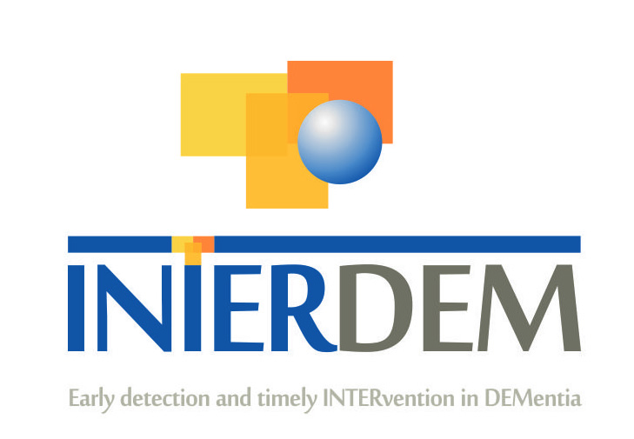

INTERDEM MEMBERS – BRIEF CURRICULUM VITAE
Please complete this document (no more than 3 pages) and return to Alice.vaneijk@radboudumc.nl
Please can you also add a picture of yourself

NAME: Catherine Talbot

TITLE: Dr

PROFESIONAL GROUPING: Academic

WORK ADDRESS:
P127, Poole House
Bournemouth University
Talbot Campus
Fern Barrow, Poole, Dorset
BH12 5BB

TEL. WORK/WORK MOBILE: N/A

EMAIL ADDRESS: ctalbot@bournemouth.ac.uk

WEBLINK: https://staffprofiles.bournemouth.ac.uk/display/ctalbot

PRESENT POSITION (e.g. Director of ………): Senior Lecturer in Psychology, Bournemouth University, UK

HIGHEST ACADEMIC QUALIFICATION (e.g. PhD, MD etc.): PhD Medical Studies, University of Exeter, UK

PROFILE OF MEMBER:
AREAS OF EXPERTISE: I am an expert in social and cyberpsychology. My research focuses on how digital technologies can be harnessed to promote wellbeing, identity, and social inclusion among people with dementia. I specialise in using qualitative research methods and I am passionate about including people with dementia in research.

KEY PUBLICATIONS (Max. 5):
Talbot, C.V., & Coulson, N.S. (2023). ‘I found it the only pace that spoke the same language’: a thematic analysis of messages posted to an online peer support discussion forum for people living with dementia. Age and Ageing, 52(1), afac330. https://doi.org/10.1093/ageing/afac330
Talbot, C.V., & Briggs, P. (2022). The use of digital technologies by people with mild-to-moderate dementia during the COVID-19 pandemic: A positive technology perspective. Dementia, 21(4), 1363-1380. https://doi.org/10.1177/14713012221079477
Giebel, C., Talbot, C.V., Wharton, E., Lorenz-Dant, K., Suarez-Gonzalez, A., Cannon, J., Tetlow, H., Lion, K. M., & Tyrian, J. R. (2022). The early impacts of COVID-19 on unpaid carers of people living with dementia: Part II of a mixed-methods systematic review. Ageing & Mental Health, 1-16. https://doi.org/10.1080/13607863.2022.2084510
Talbot, C.V., O’Dwyer, S. T., Clare, L., & Heaton, J. (2021). The use of Twitter by people with young-onset dementia: a qualitative analysis of narratives and identity formation in the age of social media. Dementia, 20(7), 2542-2557. https://doi.org/10.1177/14713012211002410
Talbot, C.V., & Briggs, P. (2021). ‘Getting back to normality seems as big of a step as going into lockdown’: the impact of the COVID-19 pandemic on people with early to middle stage dementia. Age and Ageing, 50(3), 657-663. https://doi.org/10.1093/ageing/afab012

RELEVANT RESEARCH ACTIVITY:
Please indicate for past 5 years only (i) Grants Awarded: Names of investigators; Years; Title of Project; name of awarding agency (ii) PhD and other projects: Title, start or competed date.

Talbot, C., Donellan, W., & Anderson, J. (2022). Harnessing social media to support people living with dementia: A framework to guide training and resource development. British Academy Small Research Grant. GBP £9,310.34.
May, T., Talbot, C., & Skinner, R. (2022). Improving the role of digital forensics in RASSO investigations through an evidence-based approach. Mayor’s Officer for Policing and Crime (MOPAC). GBP £499,556.66.
Acquino, R., Fong, M., & Talbot, C. (2022). NIHR Applied Research Collaboration North East and North Cumbria Methodology Summer Internship 2022. £6471.77
Renshaw-Vuillier, L., Greville-Harris, M., Moseley, R., Talbot. C. (2021). Challenging beliefs about emotion and emotion regulation through a short video intervention. Bournemouth University QR Funding. GBP £2172.89.

CURRENT RESEARCH INTERESTS/ONGOING PROJECT TITLE:
I am currently leading the British Academy funded research project “harnessing social media to support people living with dementia: a framework to guide training and resource development” (SRG22\220836). The aims of this research are to: (1) understand stakeholders’ attitudes towards people with early-stage dementia using social media; (2) co-produce resources and a training framework with people living with dementia and unpaid carers. The voices of people living with dementia and unpaid carers are centered throughout this research. I am also interested in digital inequalities faced by people affected by dementia, particularly since the COVID-19 pandemic when digital spaces became an essential part of everyday life for many people, and how the digital divide can be addressed to promote the social inclusion of people living with dementia.

One of my other research interests concerns the social health of people living with dementia. In particular, I am interested in how online spaces such as Twitter (Talbot et al., 2021) and online forums (Talbot & Coulson, under review) can facilitate social connectedness and peer support, thereby filling an important gap in current service provision.

HOW DO YOU INTEND TO CONTRIBUTE TO INTERDEM:
I am enthusiastic about joining Interdem and collaborating with researchers across Europe to improve the quality of life of people living with dementia and their supporters. I intend to contribute to Interdem by working with researchers across Europe to develop timely and quality psychosocial interventions in dementia, with a particular focus on social health, digital technologies, and health inequalities. I will work to actively disseminate the work of Interdem via my networks in the UK, including academic contacts, dementia organisations, and lived experience groups. I will also work to actively involve people affected by dementia throughout all stages of Interdem research and practice, utilising my exisiting networks (e.g., the Ageing and Dementia Research Centre Research Network; Dementia UK; the Young Dementia Network; Dementia Empowerment and Engagement Project). I am also currently a member of the taskforce on health inequalitiy, led by Dr Clarissa Giebel.With the move to digital prompted by the COVID-19 pandemic, I am particularly interested in exploring digital inequalities among those affected by dementia. I believe I have the knowledge, experience, and enthusiasm to make a positive contribution to Interdem.

Thank you for your consideration.

