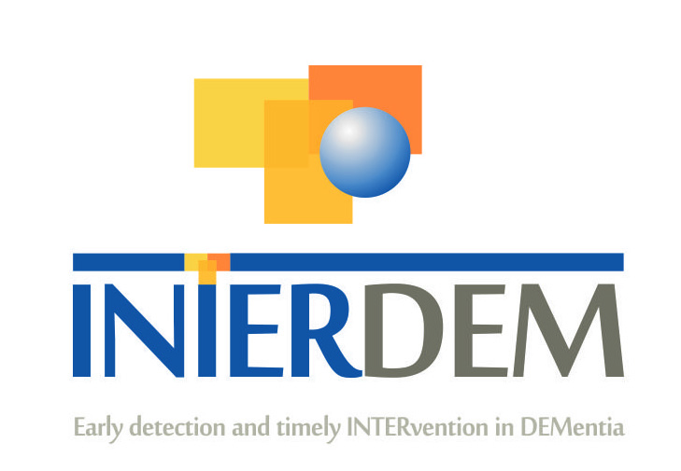

INTERDEM MEMBERS – BRIEF CURRICULUM VITAE
Please complete this document (no more than 3 pages) and return to d.moens@maastrichtuniversity.nl

Please can you also add a picture of yourself

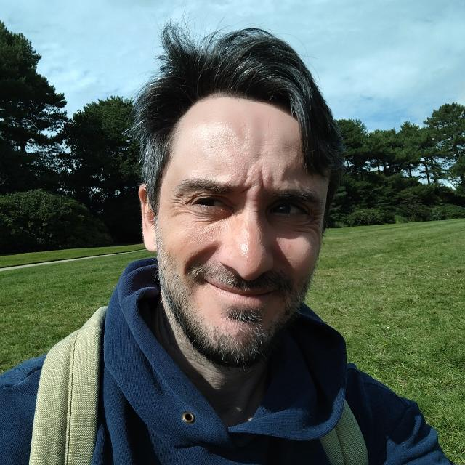

NAME: Davide Bruno

TITLE: Dr

PROFESIONAL GROUPING: Psychology

WORK ADDRESS: School of Psychology, Tom Reilly building, Byrom St., L3 3AF, Liverpool (UK)

TEL. WORK/WORK MOBILE: 0044 (0)151 904 6320

EMAIL ADDRESS: d.bruno@ljmu.ac.uk

WEBLINK:
https://www.ljmu.ac.uk/about-us/staff-profiles/faculty-of-health/school-of-psychology/davide-bruno
https://dbrunolab.wordpress.com/
Twitter: @DavideBrunoPhD

PRESENT POSITION (e.g. Director of ………): Reader in Psychology, Director of MeNu (memory and neurodegeneration research group at LJMU)

HIGHEST ACADEMIC QUALIFICATION (e.g. PhD, MD etc.): PhD

YEAR OF PHD QUALIFICATION: 2007

PROFILE OF MEMBER:

Italian-born, I studied at the University of Parma (Italy) for my BSc in Psychology, and completed a PhD at Keele University (UK), in cognitive psychology. I subsequently held post-doc positions at the University of Southampton (UK), the University of Massachusetts – Amherst (USA), and the Nathan Kline Institute for Psychiatric Research (USA). I was also Research Assistant Professor at New York University (USA), before taking up a Lectureship at Liverpool Hope University (UK).
I am currently a Reader in Psychology at Liverpool John Moores University.

AREAS OF EXPERTISE:

Memory assessment, memory theory, early detection of dementia, neurocognitive assessment, dementia biomarkers

KEY PUBLICATIONS (Max. 5):

Bruno, D., Zinkunegi, A. J., Kollmorgen, G., Suridjan, I., Wild, N., Carlsson, C., ... & Mueller, K. D. (2023). The recency ratio assessed by story recall is associated with cerebrospinal fluid levels of neurodegeneration biomarkers. Cortex, 159, 167-174.
Frau, L., Cazzato, V., McGlone, F., & Bruno, D. (2022). The effects of multimodal training on working memory in younger and older adults. The Cognitive Psychology Bulletin, 7, 23-35.
Bruno, D., & Rutherford, A. (2022). Cognitive ability in former professional football (soccer) players is associated with estimated heading frequency. Journal of neuropsychology, 16(2), 434-443.
Bruno, D., Mueller, K. D., Betthauser, T., Chin, N., Engelman, C. D., Christian, B., ... & Johnson, S. C. (2020). Serial position effects in the Logical Memory Test: Loss of primacy predicts amyloid positivity. Journal of Neuropsychology.
Bruno, D., Koscik, R. L., Woodard, J. L., Pomara, N., & Johnson, S. C. (2018). The recency ratio as predictor of early MCI. International Psychogeriatrics, 1-6.

RELEVANT RESEARCH ACTIVITY:
Please indicate for past 5 years only (i) Grants Awarded: Names of investigators; Years; Title of Project; name of awarding agency (ii) PhD and other projects: Title, start or competed date.

Funding:

Grant – Principal Investigator for LJMU: 2020-2025 - $1,400,000 ($216,770 direct funding) for a project titled “Novel story recall measures as indicators of cognitive decline associated with Alzheimer’s disease and related disorders biomarkers: a collaborative study of existing data” (R01 AAI8612). NIA-NIH (USA)
Grant – Co-Investigator: 2018 - ¥997,001 for a project titled “Developing and validating a survey method for determining amount of football heading done over a football career”. The Univers Foundation (Japan)
Grant - Principal Investigator: 2018 - £1,200 for the Higher Education Innovation Fund (Liverpool John Moores University)

PhD:

Exploring the role of cognitive reserve and emotional modulation: Implications for executive function in multimodal interventions across age groups. Submitted Oct 23, 2023, Viva in December 2023

The immediate and accumulative effects of ball heading on neurocognitive function within recreational football players. Started Jun 1, 2022

Input and output order of recall as early markers of cognitive decline. Project completed and PhD awarded in 2019

CURRENT RESEARCH INTERESTS/ONGOING PROJECT TITLE:

My main current area of research is low cost / high acceptability tools for early detection of Alzheimer’s (and related disorders) pathology.

HOW DO YOU INTEND TO CONTRIBUTE TO INTERDEM:

I will outline below how I think my research may fit within the overall scope of your work.

We are concerned with the fact that dementia diagnosis is moving towards a biomarker approach, as opposed to one that is founded upon clinical/neuropsychological diagnosis. A reason for concern, in my view, is that this approach will lead to diagnoses only when expensive technology, which requires specialised training, is available – however, this technology will not be equally available within countries (e.g., city vs. rural areas), or across countries. Moreover, minorities tend to be less likely to engage in screening measures that are more intimidating, thus leading to furthering inequality and leading to uneven rates of diagnosis. Therefore, we have worked at improving existing tests so that they can provide more sensitivity at no added cost (or effort) to clinicians.

In relationship specifically to psychosocial interventions, our work can help identify individuals who, despite not showing any obvious signs of the disease, may present with subtler issues, and thus might benefit more from interventions. Moreover, we can aid the assessment of intervention success, by proving researchers with novel, sensitive, low cost ways to evaluate people’s performance before and after a psychosocial trial.

Additionally, I do have experience in applying psychosocial interventions, as we have evaluated the impact of affective touch on the well-being and stress of older adults, alongside their cognitive ability – I believe we are the first to show that affective touch can improve cognitive performance in older individuals, after a short intervention. More research is needed here, and currently planned.

Moreover, we have explored the associations between diet (MIND) and other life-long conditions (particularly depression and hormone-replacement therapy) on risk of dementia. Currently also working with colleagues and private companies interested in incorporating AI and machine learning with cognitive theory.

